

**Project Overview**

**Course: SCD**

**Submitted to: Maam Fatima Gillani**

**Submitted by: Adil Bilal (FL21499)**

**Sana Bushra (FL21526)**

**Section: BSSE-5B**

# Use-case Diagram

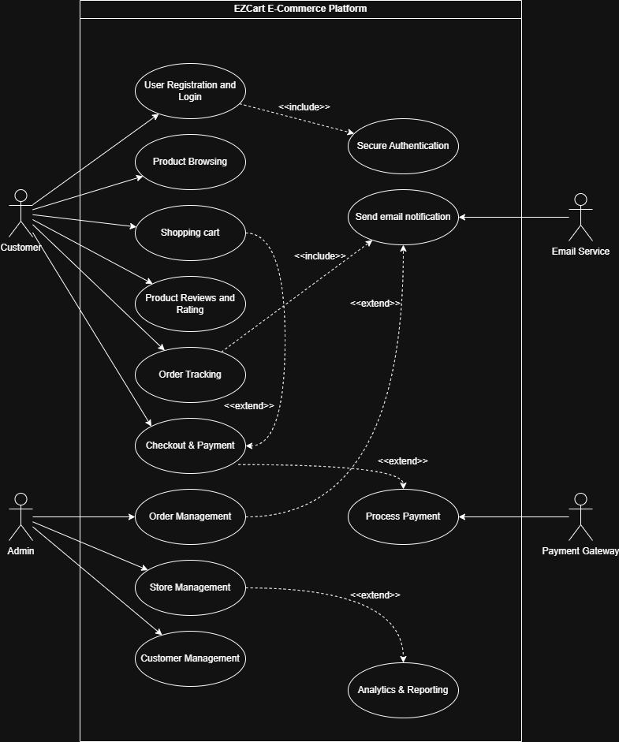

# Object Diagram

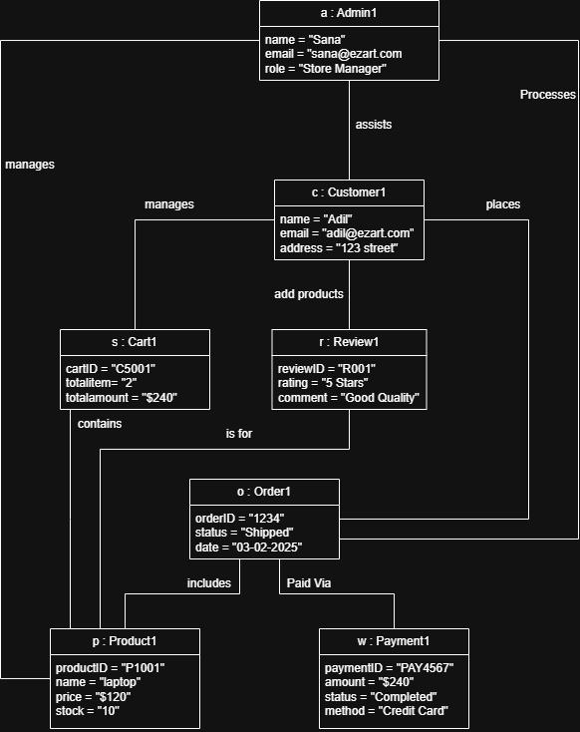

# Sequence Diagram

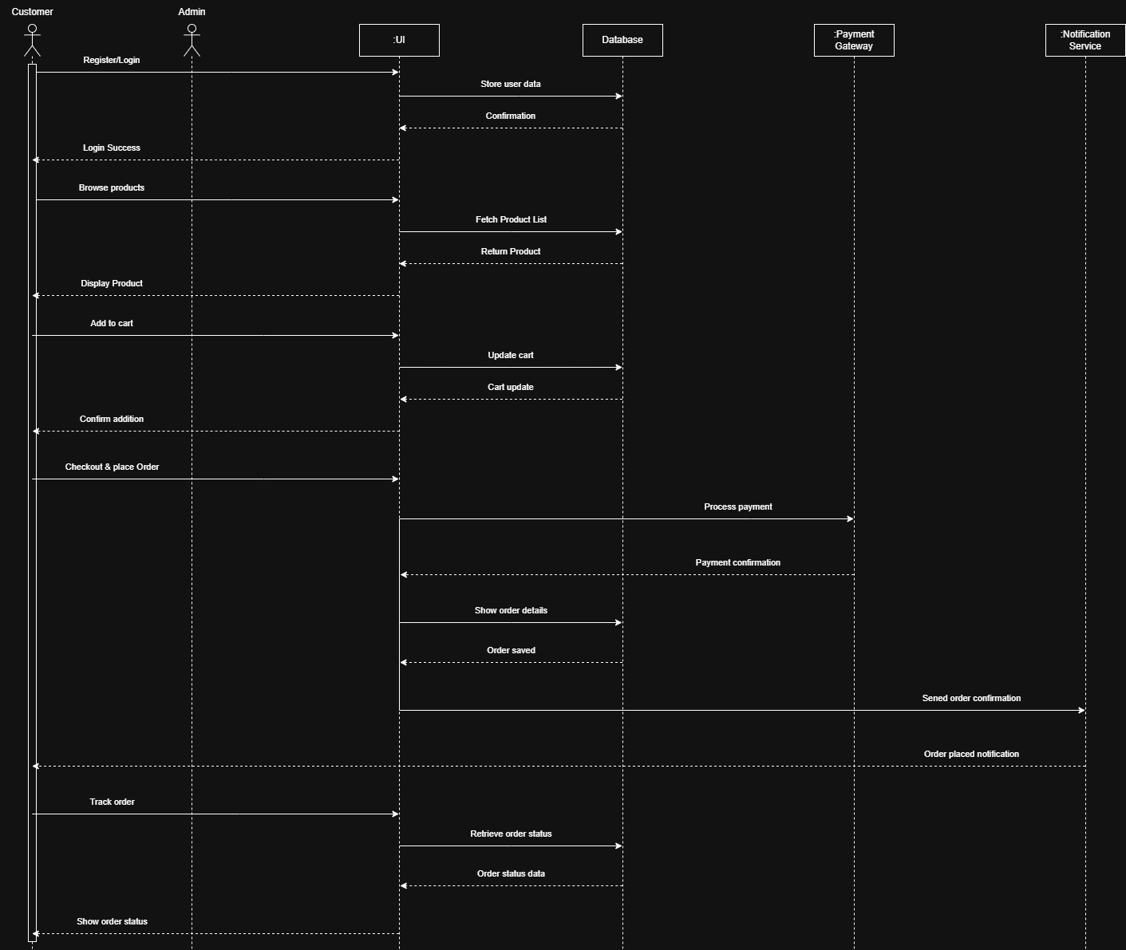

# Timing Diagram

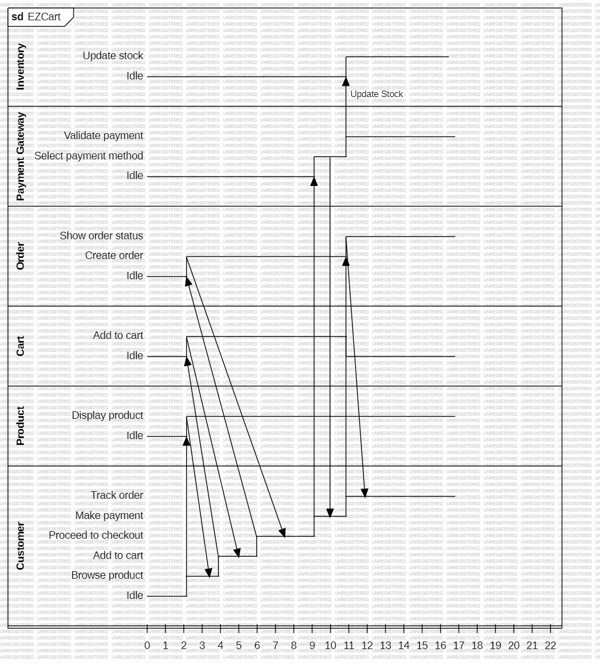

Order status shown

Check order status

Payment successful

Process payment

Order created

Create order

Item added confirmation

Request product details

Add item to cart

Send product details

# Petri Nets